Exercise: Indicating business performance

Introduction
Your manager, Adio, asks you to prepare a report for the sales team at Adventure Works displaying key performance indicators (KPIs). The stakeholders need your report to answer a variety of KPI-related questions, including:
- What are the total sales and average sales?
- What are the monthly total sales?
- What is the total number of orders placed during this time period?
- What is the total marketing expenditure, and what is the monthly marketing expenditure?
- What is the change in sales over time for the sales teams, and how does this correlate with marketing spending?
- What sales region had the highest sales during this time period, and how did their ranking change over time?
- What is the performance of different sales regions with their advertising campaigns?
To complete this task, your manager provides you with a sales dataset for the last three months containing total sales volume and advertising spending for various sales regions. Each of these regions runs different advertising campaigns.
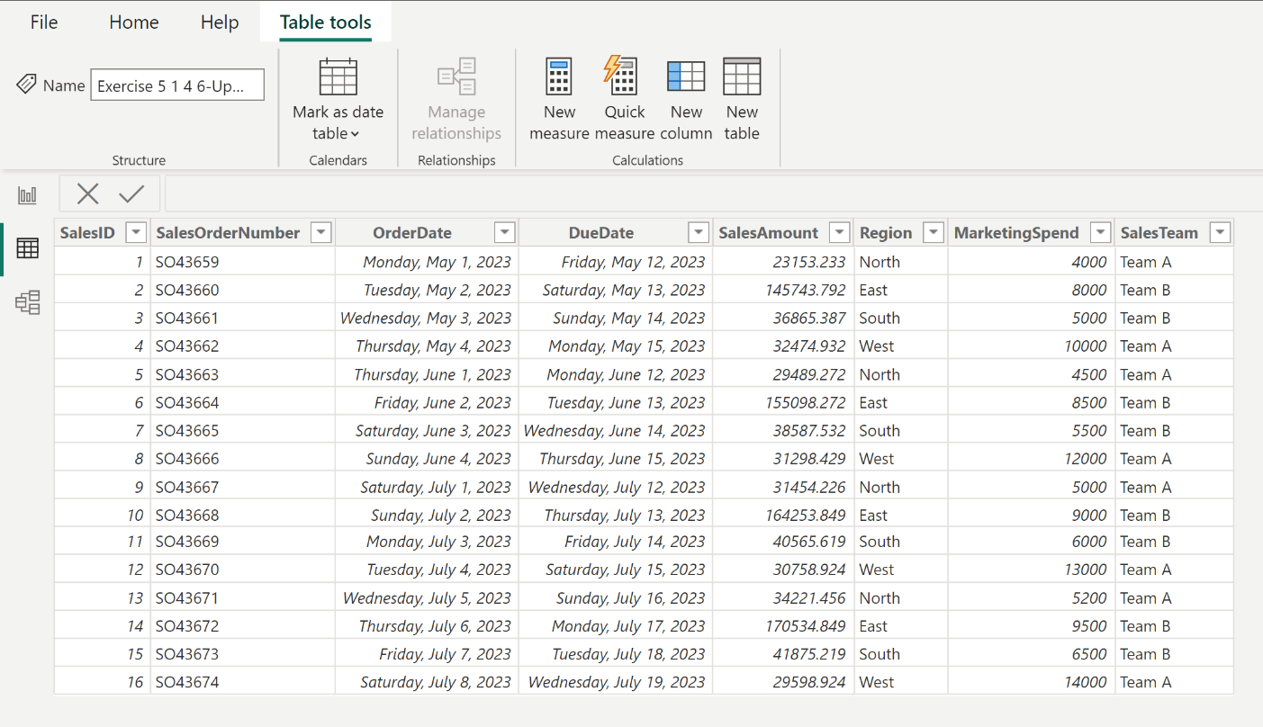
In this exercise, you’ll apply your knowledge of specialist visualizations, such as waterfall and ribbon charts, to create visualizations for the sales report that will convey the required insights

Instructions

Step 1: Load the data
Load the Indicating business performance dataset into Power BI Desktop.

Step 2: Compute the metrics and create visualizations
Based on the stakeholders’ needs, you identify the following as KPIs relevant to the sales teams:
- Total sales
- Average sales
- Total sales per month
- Total orders
- Total and monthly marketing spend
- Sales change over time for sales teams and in relation to marketing spend
- Highest sales region
- Sales ranking changes
Compute the key performance indicators (KPIs) for the sales data and represent them using the appropriate visualizations by completing the following steps:
- Total sales and average sales
- Create a card visualization to compute the total sales using the Sales Amount data field.
- Create a card visualization to compute average sales using the Sales Amount data field. Tip: Make sure the Fields field is set to Average.
- Total sales per month
- Create a multi-row card visualization to compute the total sales for each month using the Order Date and Sales Amount data fields.
- Total orders
- Create a card visualization to compute the total number of orders using the Sales ID data field.
- Total and monthly marketing spend:
- Create a card visualization to compute the total marketing spend using the Marketing Spend data field.
- Create a multi-row card visualization to compute the monthly marketing spend using the Order Date and Marketing Spend data fields.
- Total marketing spend in relation to monthly marketing spend
- Create a waterfall chart to show how the sales have changed over time for the different sales teams and how this change correlates with the marketing spend. Use the Sales Amount, Month, and Sales Team data fields.
- Tip: Place the Marketing Spend data field into the Tooltips field well to gain insight into the correlation between marketing spend and sales changes.
- Region performance and ranking:
- Create a ribbon chart to identify the region with the highest sales during this period and visualize how their ranking has changed over time using the Sales Amount, Month, and Sales Region data fields.
- Tip: Place the Marketing Spend and Sales Team data fields into the Tooltips field well to gain insight into the factors that influence sales performance in different regions, and how marketing strategies and teams contribute to the overall result.

Step 3: Communicate results
In a Word document, write a few sentences about each visualization, communicating the results of your analysis to support the stakeholders’ understanding. Ensure you address the sales team’s questions in your written report:
- What are the total sales and average sales?
- What are the monthly total sales?
- What is the total number of orders placed during this time period?
- What is the total marketing expenditure, and what is the monthly marketing expenditure?
- What is the change in sales over time for the sales teams, and how does this correlate with marketing spending?
- What sales region had the highest sales during this time period, and how did their ranking change over time?
- What is the performance of different sales regions with their advertising campaigns?

Step 4: Save your work
Save your report and analysis write-up for future use.

Conclusion
In this exercise, you consolidated your understanding of the significance and use of KPIs in a business context. You experienced ways of extracting meaningful insights from raw data by calculating and visualizing specific KPIs such as total sales, average sales, number of orders, and marketing expenditure. Additionally, you learned to relate different KPIs to each other to unearth deeper insights, for instance, how sales trends are affected by marketing spending, and had the opportunity to tackle anomalies in data, such as identifying regions where high marketing spend does not translate to high sales.

